Water Quality Monitoring & Forecasting System

In this project we are using water dataset to predict and forecast water quality by using algorithms such as LSTM and Random Forest and in both algorithms Random Forest is giving better accuracy. After training model we are applying test data on train model to predict the quality of the test data and below screen showing test DATA values

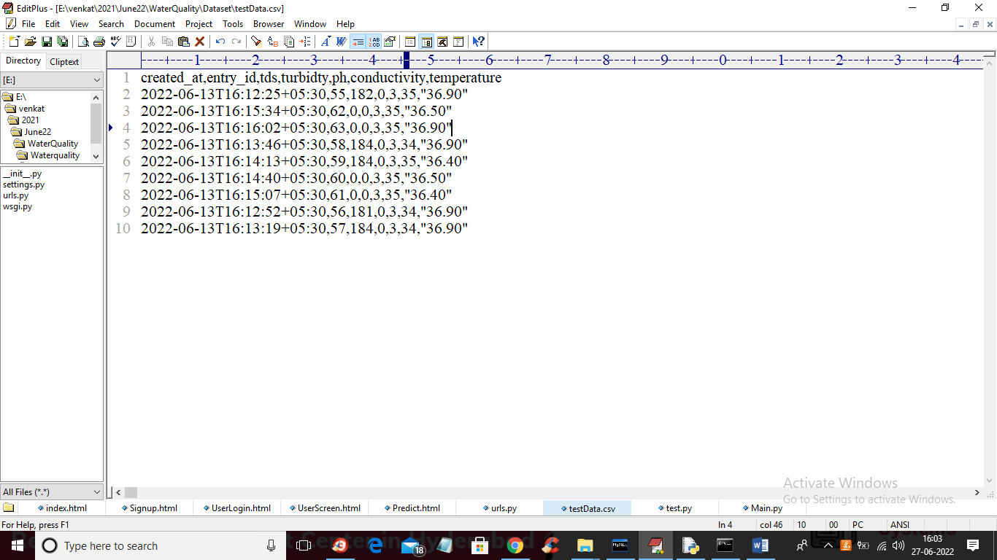

In above test data screen we have all water quality values but we don’t GOOD and POOR label so when we applied on algorithm trained model then it will forecast GOOD or Poor Quality.

SCREEN SHOTS

To run project first copy content from ‘DB.txt’ file and then paste in MYSQL database to create it and now double click on ‘run.bat’ file to start DJANGO server and then will get below output

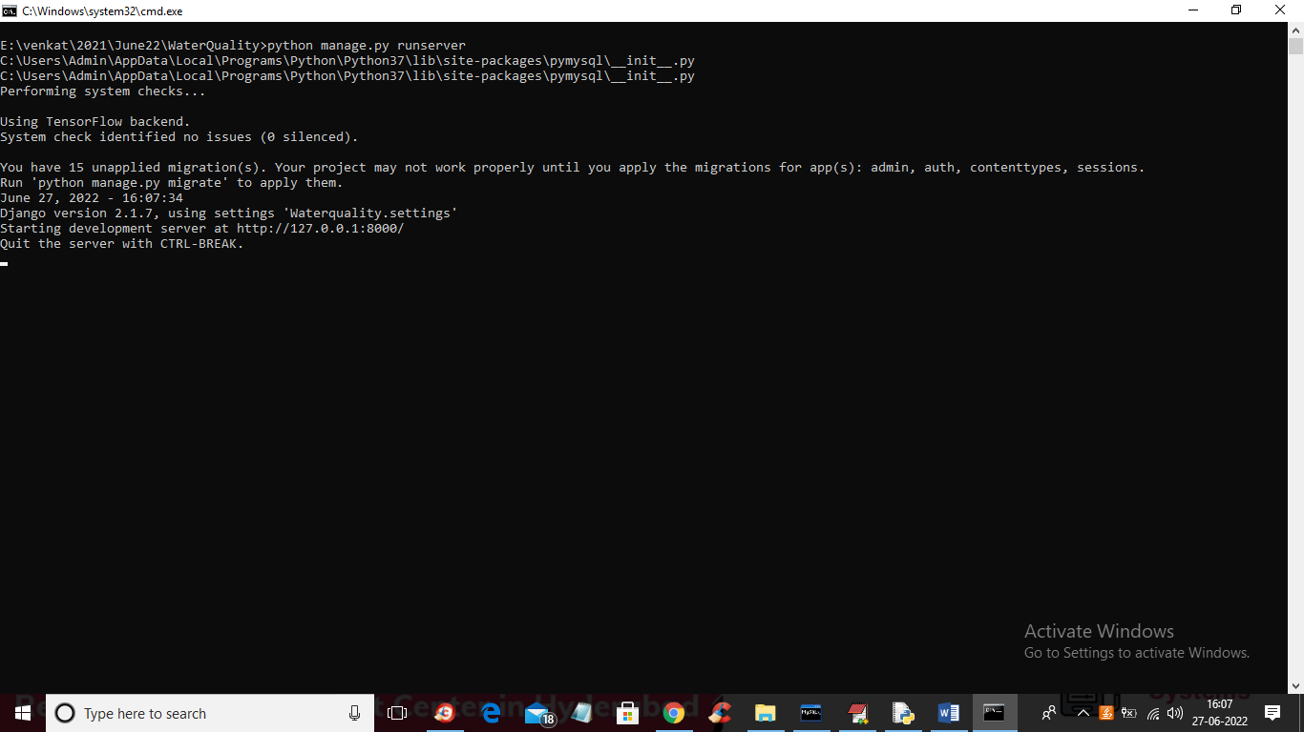

In above screen DJANGO server started and now open browser and enter URL as ‘http://127.0.0.1:8000/index.html’ and press enter key to get below page

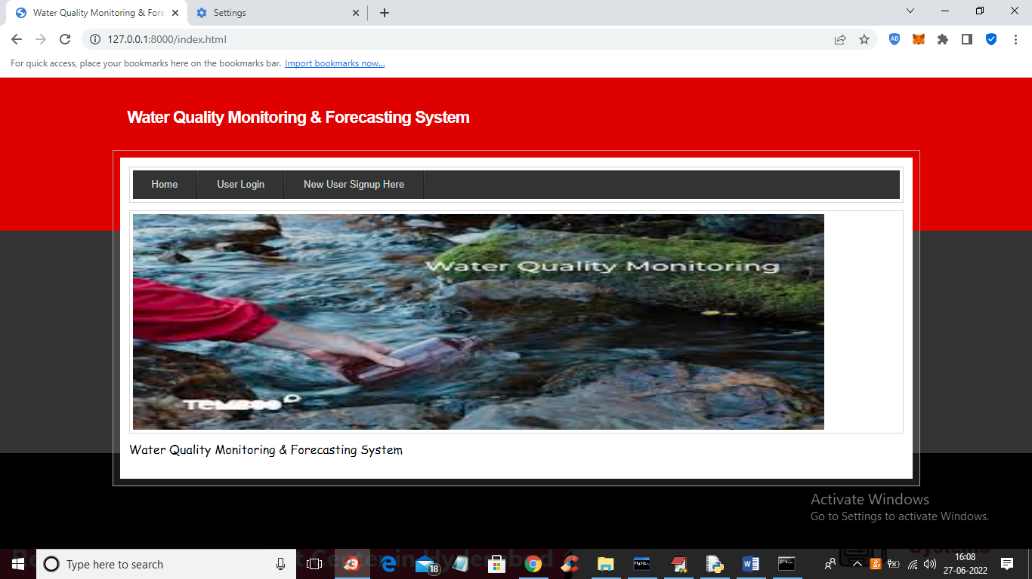

In above screen click on ‘New User Signup Here’ link to get below screen

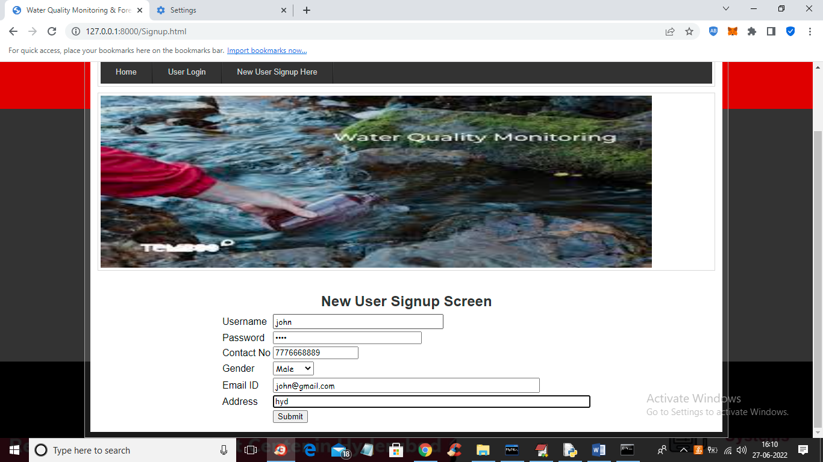

In above screen user is signing up and then press button to get below screen

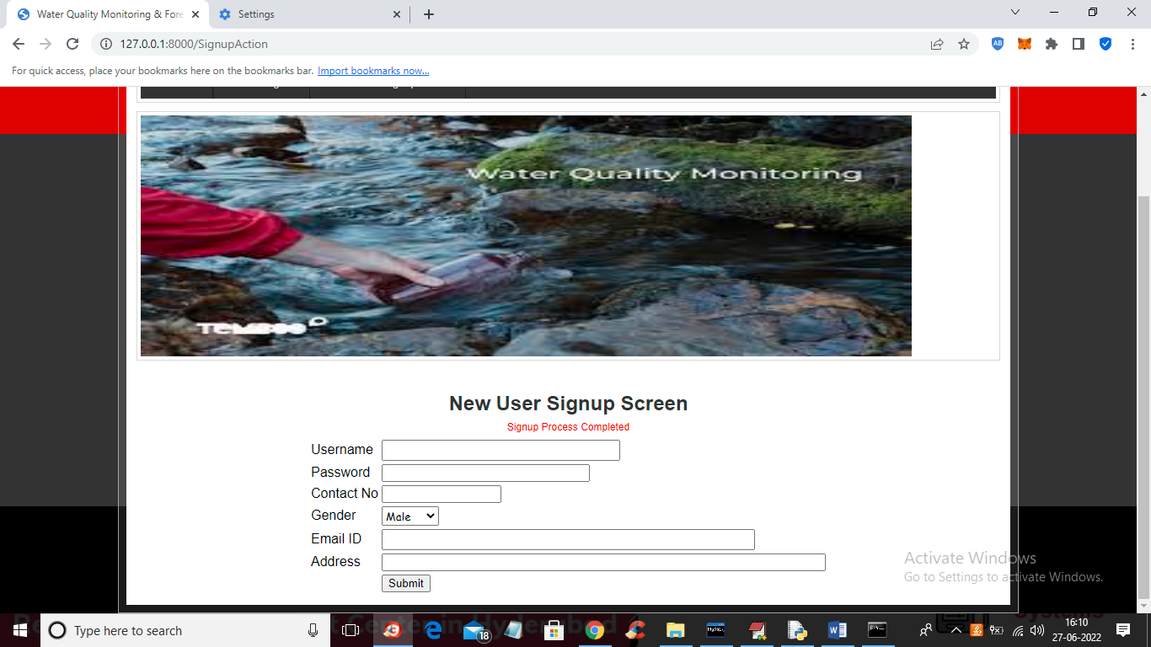

In above screen signup process completed and now click on ‘User Login’ link to get below screen

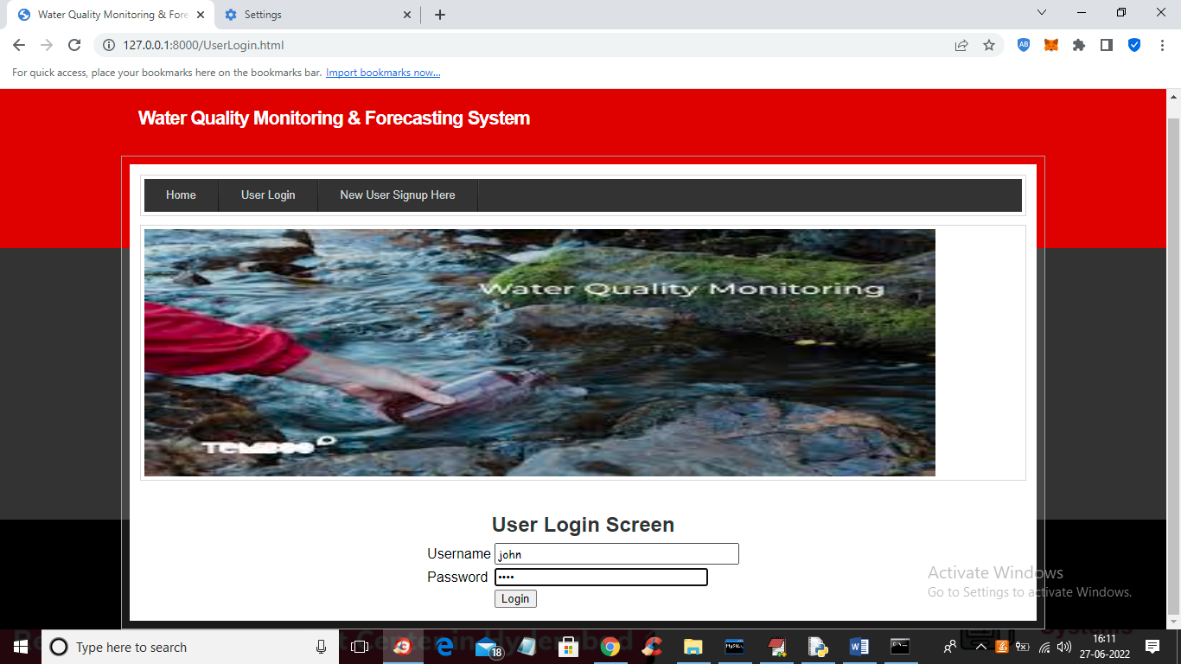

In above screen user is login and after login will get below screen

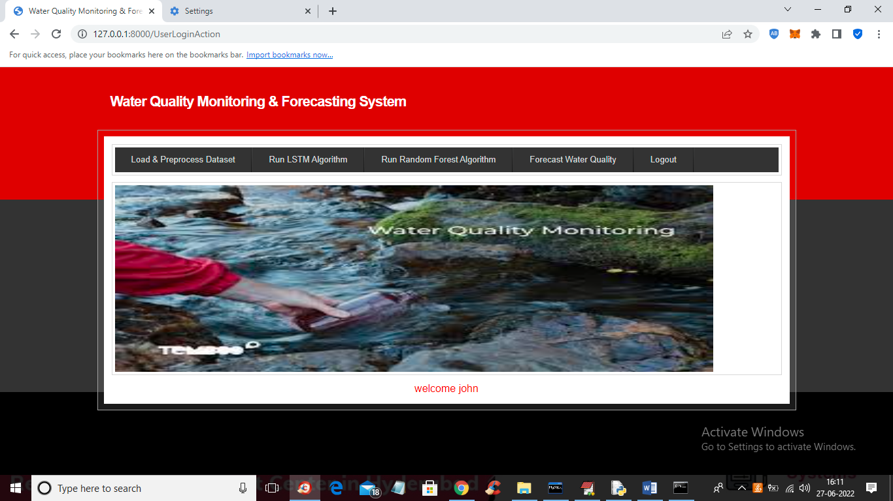

In above screen click on ‘Load & Preprocess Dataset’ link to load and process dataset such as replacing missing values with 0 and then split dataset into train and test and get below output

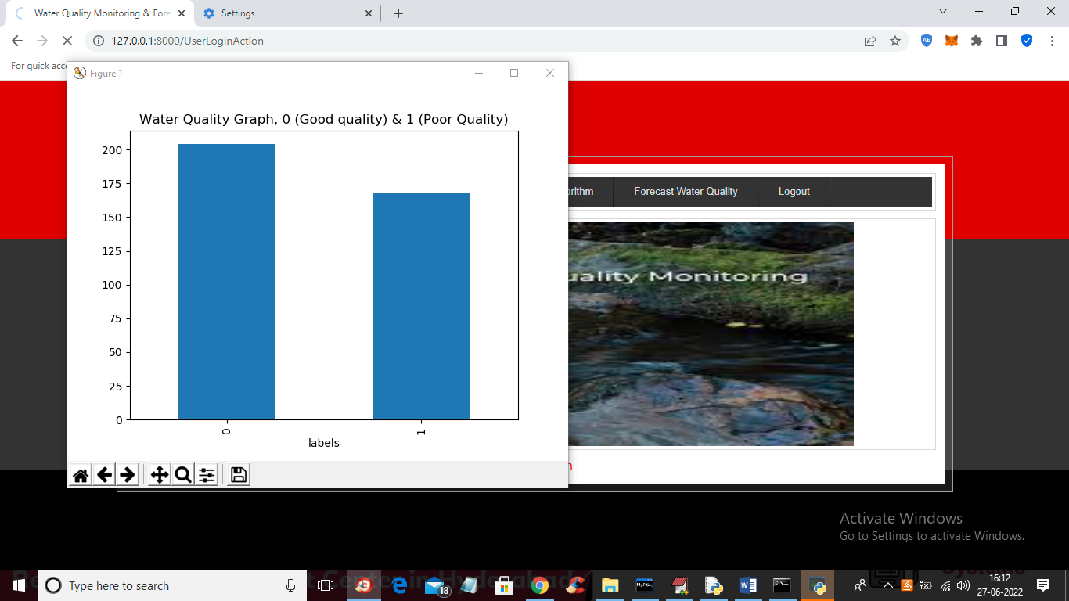

In above screen dataset is processed and in above graph x-axis contains water quality as 0 or 1 where 0 means GOOD quality and 1 means POOR quality and y-axis represents number of records and now close above graph to get below screen

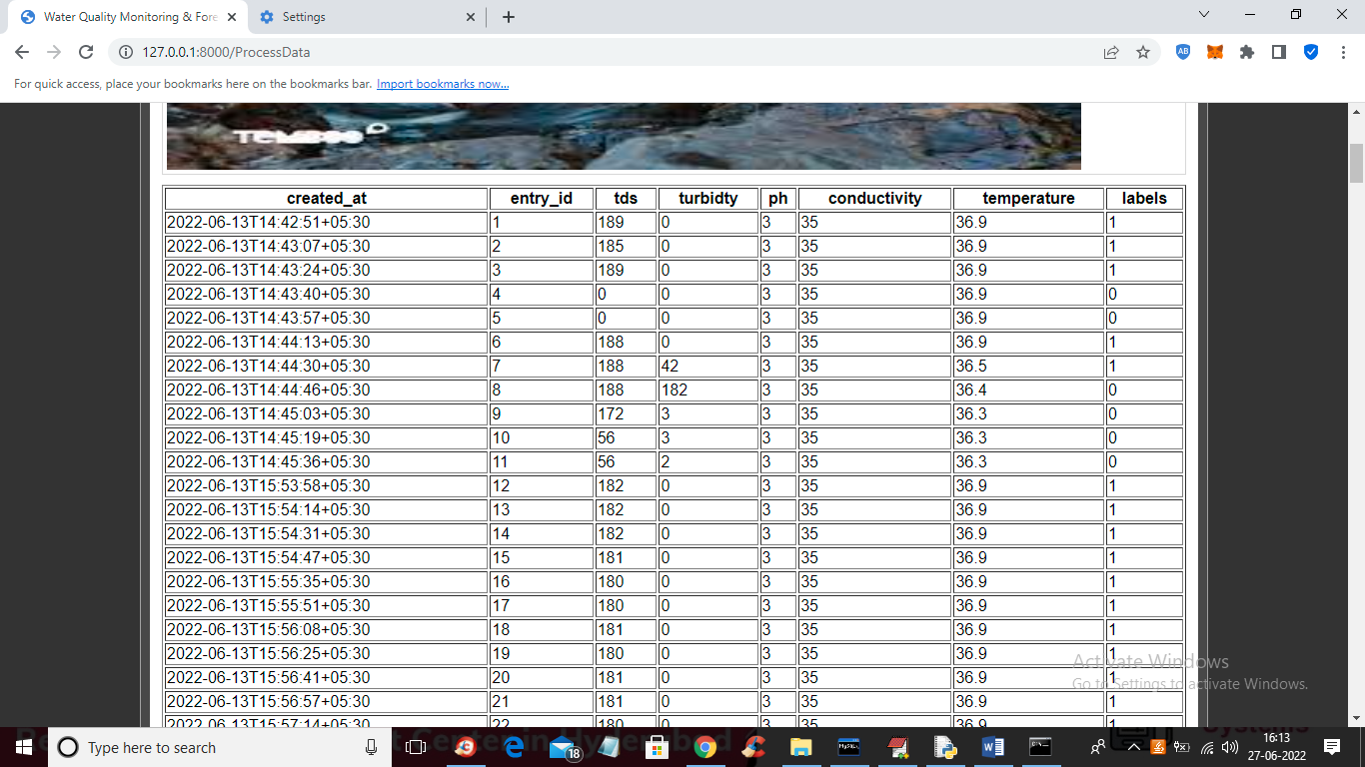

In above screen we can see dataset processed and loaded and now click on ‘Train LSTM Algorithm’ link to train LSTM and get below output

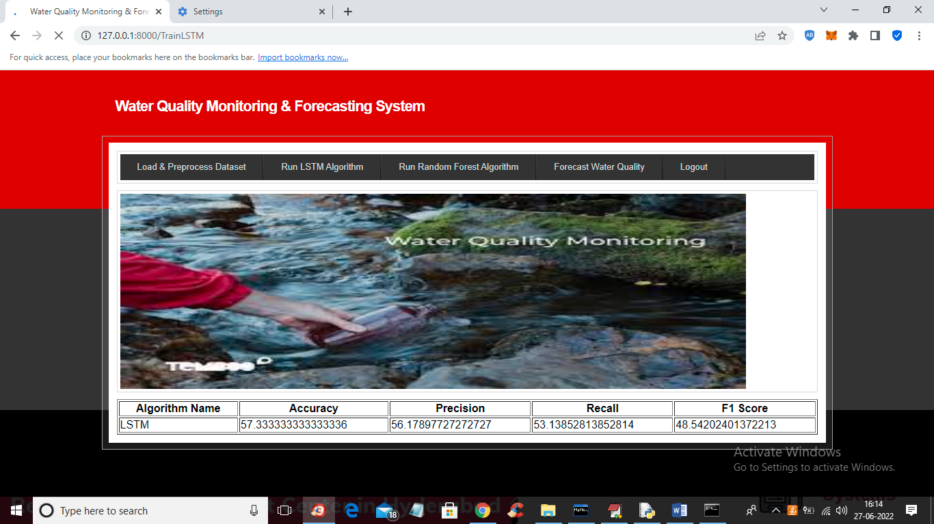

In above screen LSTM got trained and with LSTM we got 57% accuracy and now click on ‘Train Random Forest Algorithm’ link to train Random Forest and get below output

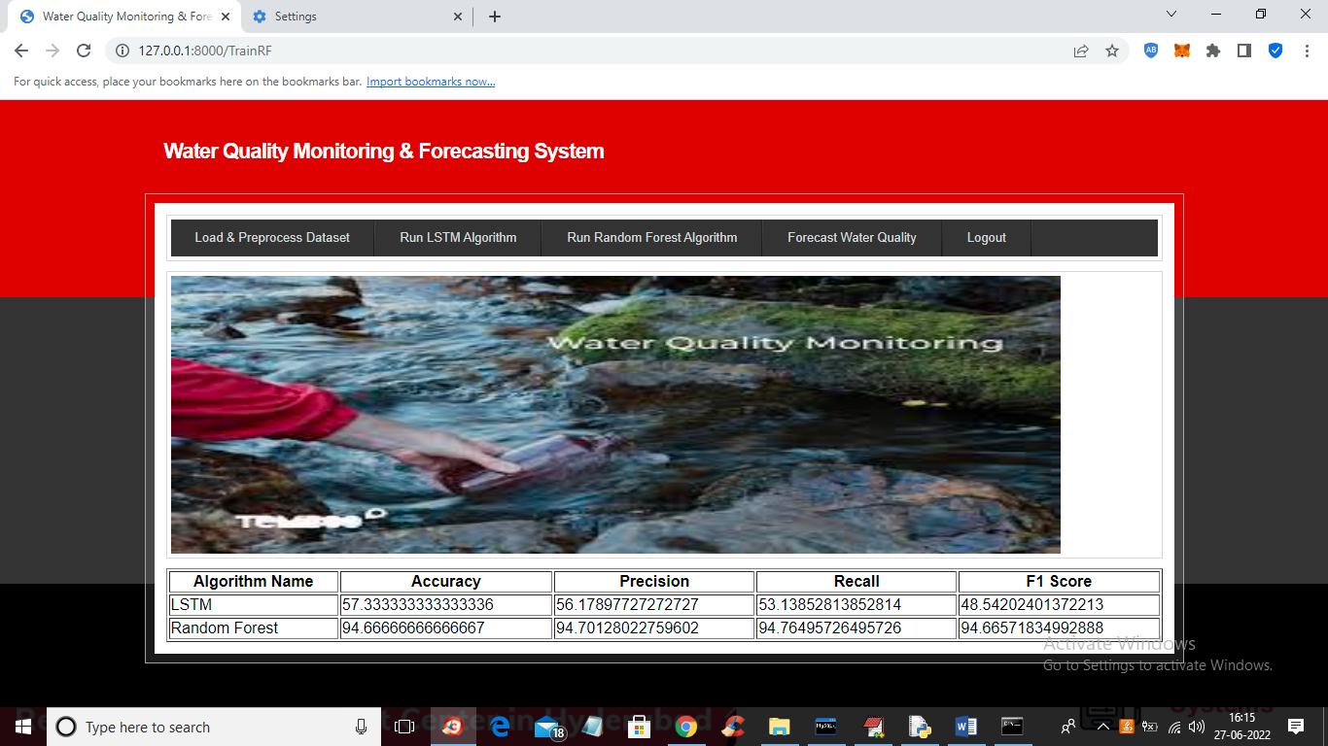

In above screen with Random Forest we got 94% accuracy and now click on ‘Forecast Water Quality’ link to upload test data and then forecast quality

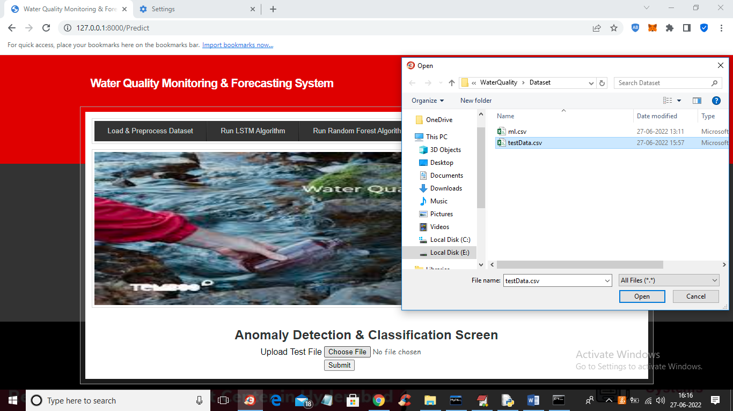

In above screen selecting and uploading ‘testData.csv’ file and then click on ‘Open’ and ‘Submit’ button to get below forecast output

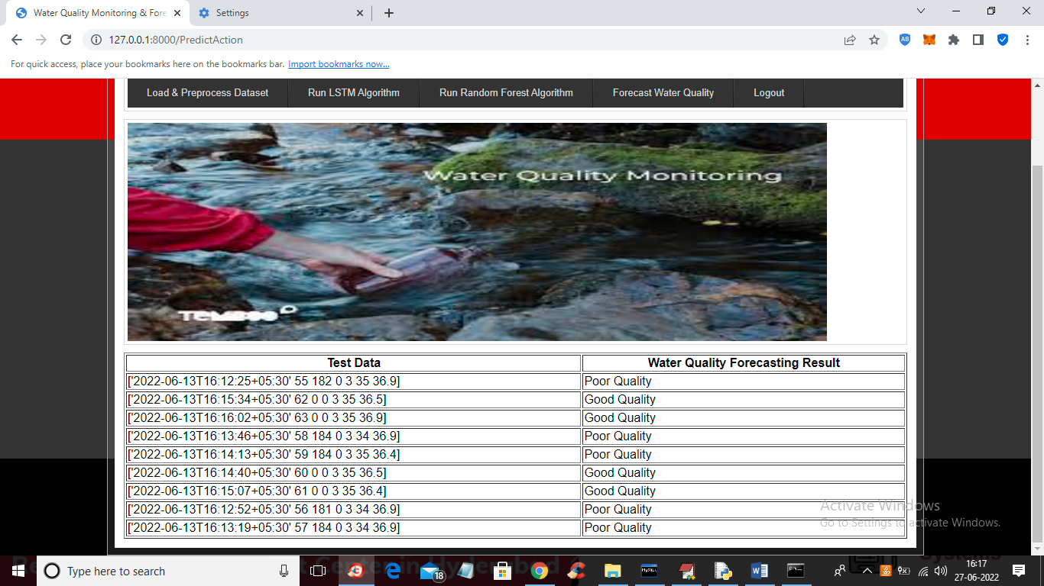

In above screen in tabular output first column contains water test values and second column contains forecast result as ‘Poor’ or “Good”